## Image result for MLRITM LOGOTITLE:INTELLIGENT ROBOT USING IBM WATSON PLATFORM

TEAM NAME:**FIX IT IOT**

**DONE BY**

S.Pranav

A.Shreya

V.Jahnavi

**ABSTRACT**

**Wi-fi**is controlled by using a android application. Here we use node-red and ibm watson platform to create an app using mit app inventor to control the car in forward, backward, left and right directions. So here Node MCU is used as a transmitting device and indult wi-fi module placed in the car is used as a receiver. Aurdino software will transmit command from serial monitor using wi-fi to the car so that it can move in the required direction like moving forward, reverse, turning left, turning right and stop.

Wireless technology in Robotics starts with Bluetooth, WI-FI, and Zigbee Communication. Based on the Requirement and Application they deployed the communication in Projects. And we have numerous android Applications in Play store to control a Robot car. Blynk is a Popular App used in this Project it has a lot of Features like buttons, gauges, Sliders and Plotting Features also. By using Wi-Fitechnologywe can connect a greater number of Robotic Car to control it very useful for surveillance application. Now a day’s Indoor localization Technologies are developed on that case also we can deploy this type of Wi-Fi-controlled Robotic Car.

Now a day the advancement in technology various new designed smart makes use of Wi-Fi robot for various applications. Mostly wi-fi network was using home security purpose. The various applications are done by robot car like doing different works on the command ex- switching on the lights when the robot is given the command by the Wi-Fi enabled device.

The car was controlled by the wi-fi network inmit app inventor where the directions are uploaded using node red and IBM watson sevices. The wi-fi robot car can be easily moved from one place to another place by using the command. We can make the car do the various task using wi-fi network technologies.

**HARDWARE COMPONENTS**

* **Nodemcu ESP8266 controller**

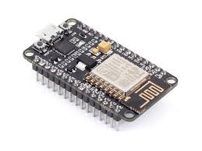

**HOW DOES IT WORK?????**

**NodeMCU** is an open source IOT platform. It includes firmware which runs on the ESP8266 WIFI SOC from [Espressif Systems](https://en.wikipedia.org/w/index.php?title=Espressif_Systems&action=edit&redlink=1), and hardware which is based on the ESP-12 module.

The chip first came to the attention of western [makers](https://en.wikipedia.org/wiki/Maker_culture) in August 2014 with the **ESP-01** module, made by a third-party manufacturer Ai-Thinker. This small module allows microcontrollers to connect to a Wi-Fi network and make simple TCP/IP connections using [Hayes](https://en.wikipedia.org/wiki/Hayes_command_set)-style commands. However, at first there was almost no English-language documentation on the chip and the commands it accepted.[]](https://en.wikipedia.org/wiki/ESP8266#cite_note-2) The very low price and the fact that there were very few external components on the module, which suggested that it could eventually be very inexpensive in volume, attracted many hackers to explore the module, chip, and the software on it, as well as to translate the Chinese documentation.

The **ESP8285** is an ESP8266 with 1 MiB of built-in flash, allowing for single-chip devices capable of connecting to Wi-Fi.

The successor to these microcontroller chips is the [ESP32](https://en.wikipedia.org/wiki/ESP32), released in 2016.

|  |  |
| --- | --- |
| **Manufacturer** | Espressif Systems |
| **Type** | 32-bit microcontroller |
| [**CPU**](https://en.wikipedia.org/wiki/Central_processing_unit) | @ 80 MHz (default) or 160 MHz |
| **Memory** | 32 KiB instruction, 80 KiB user data |
| **Input** | 16 GPIO pins |
| **Successor** | [ESP32](https://en.wikipedia.org/wiki/ESP32) |

* **DC Motor**

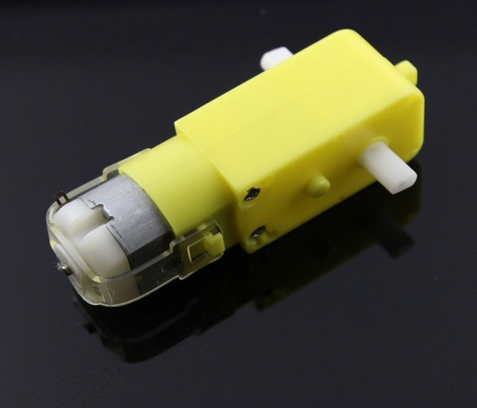

A **DC motor** is any of a class of rotary electrical machines that converts direct current electrical energy into mechanical energy. The most common types rely on the forces produced by magnetic fields. Nearly all types of DC motors have some internal mechanism, either electromechanical or electronic, to periodically change the direction of current flow in part of the motor.

DC motors were the first form of motor widely used, as they could be powered from existing direct-current lighting power distribution systems. A DC motor's speed can be controlled over a wide range, using either a variable supply voltage or by changing the strength of current in its field windings. Small DC motors are used in tools, toys, and appliances. The [universal motor](https://en.wikipedia.org/wiki/Universal_motor) can operate on direct current but is a lightweight [brushed](https://en.wikipedia.org/wiki/Brush_(electric)) motor used for portable power tools and appliances. Larger DC motors are currently used in propulsion of electric vehicles, elevator and hoists, and in drives for steel rolling mills. The advent of power electronics has made replacement of DC motors with [AC motors](https://en.wikipedia.org/wiki/AC_motors) possible in many applications.

The **DC motor** is the device which converts the **direct current** into the mechanical work. It works on the **principle** of Lorentz Law, which states that “the current carrying conductor placed in a magnetic and electric field experience a force”. And that force is called the Lorentz force.

**What is lorentz force??**

**Lorentz** force, the force exerted on a charged particle q moving with velocity v through an electric E and magnetic field B. The entire electromagnetic force F on the charged particle is called the**Lorentz** force

* **Motor Driver L293D**

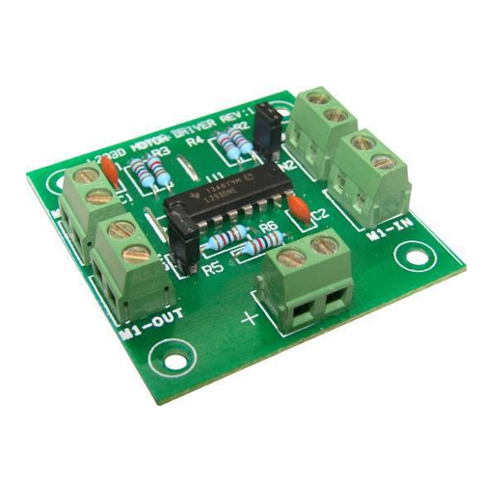A **DC motor** is any of a class of rotary electrical machines that converts direct current electrical energy into mechanical energy. The most common types rely on the forces produced by magnetic fields. Nearly all types of DC motors have some internal mechanism, either electromechanical or electronic, to periodically change the direction of current flow in part of the motor.

DC motors were the first form of motor widely used, as they could be powered from existing direct-current lighting power distribution systems. A DC motor's speed can be controlled over a wide range, using either a variable supply voltage or by changing the strength of current in its field windings. Small DC motors are used in tools, toys, and appliances. The [universal motor](https://en.wikipedia.org/wiki/Universal_motor) can operate on direct current but is a lightweight [brushed](https://en.wikipedia.org/wiki/Brush_(electric)) motor used for portable power tools and appliances. Larger DC motors are currently used in propulsion of electric vehicles, elevator and hoists, and in drives for steel rolling mills. The advent of power electronics has made replacement of DC motors with [AC motors](https://en.wikipedia.org/wiki/AC_motors) possible in many applications.

L293D is a typical Motor driver or Motor Driver IC which allows DC motor to drive on either direction. L293D is a 16-pin IC which can control a set of two DC motors simultaneously in any direction. It means that you can control two [DC motor](https://www.rakeshmondal.info/High-Torque-Motor-Low-RPM-Motor) with a single L293D IC. Dual H-bridge Motor Driver integrated circuit (IC).

The l293d can drive small and quiet big motors as well, check the Voltage Specification at the end of this page for more info.

You can Buy L293D IC in any electronic shop very easily and it costs around 70 Rupees (INR) or around 1 $ Dollar (approx Cost) or even lesser cost. You can find the necessary pin diagram, working, a circuit diagram, Logic description and Project as you read through.

* **5 Volt Battery**

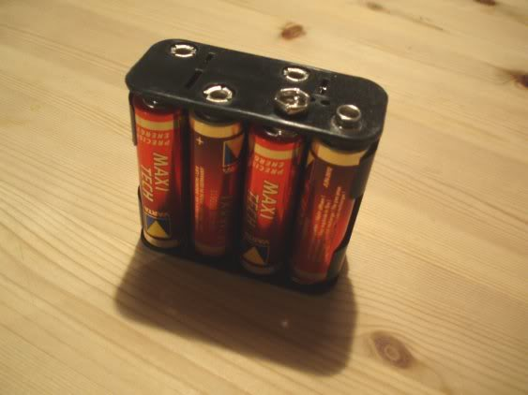

**SOFTWARE REQUIREMENTS**

* **Arduino IDE**

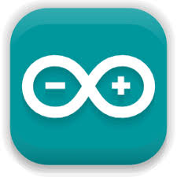

The open-source **Arduino Software** (**IDE**) makes it easy to write code and upload it to the board. It runs on Windows, Mac OS X, and Linux. The environment is written in Java and based on Processing and other open-source software.

* **NODE-RED**

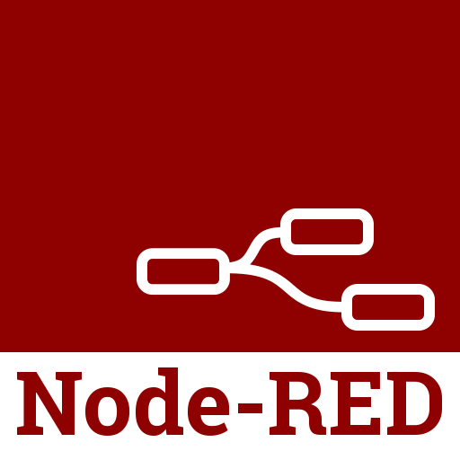

**Node-RED** is a [flow-based](https://en.wikipedia.org/wiki/Flow-based_programming) development tool for [visual programming](https://en.wikipedia.org/wiki/Visual_programming_language) developed originally by [IBM](https://en.wikipedia.org/wiki/IBM) for wiring together hardware devices, [APIs](https://en.wikipedia.org/wiki/Application_programming_interface) and [online services](https://en.wikipedia.org/wiki/Online_services) as part of the [Internet of Things](https://en.wikipedia.org/wiki/Internet_of_Things).[[2]](https://en.wikipedia.org/wiki/Node-RED#cite_note-2)

Node-RED provides a [web browser](https://en.wikipedia.org/wiki/Web_browser)-based flow editor, which can be used to create [JavaScript](https://en.wikipedia.org/wiki/JavaScript) functions. Elements of applications can be saved or shared for re-use. The runtime is built on [Node.js](https://en.wikipedia.org/wiki/Node.js). The flows created in Node-RED are stored using [JSON](https://en.wikipedia.org/wiki/JSON). Since version 0.14 [MQTT](https://en.wikipedia.org/wiki/MQTT) nodes can make properly configured [TLS](https://en.wikipedia.org/wiki/Transport_Layer_Security) connections.

**BLOCK DIAGRAM**

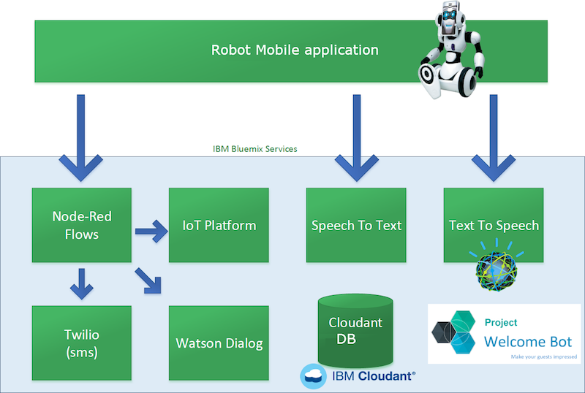

**PROCEDURE**

* **Login to your IBM cloud account.**
* **Launch NODE-RED which is IBM Watson IOT platform.**
* **Create a user interface between Watson service and the device.**
* **Open MIT app inventor and create a mobile application for your respective project.**
* **After dumping the code in the NODE MCU ,install the app (MIT application) which helps you in controlling the movement of the robot car.**

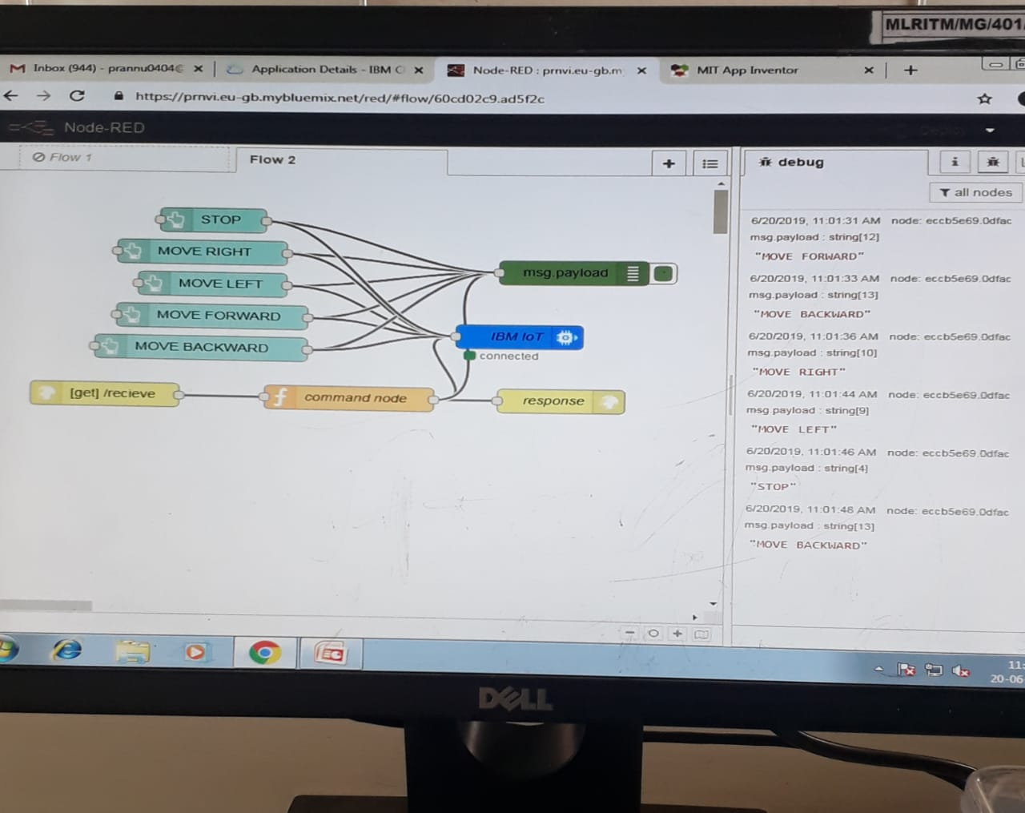

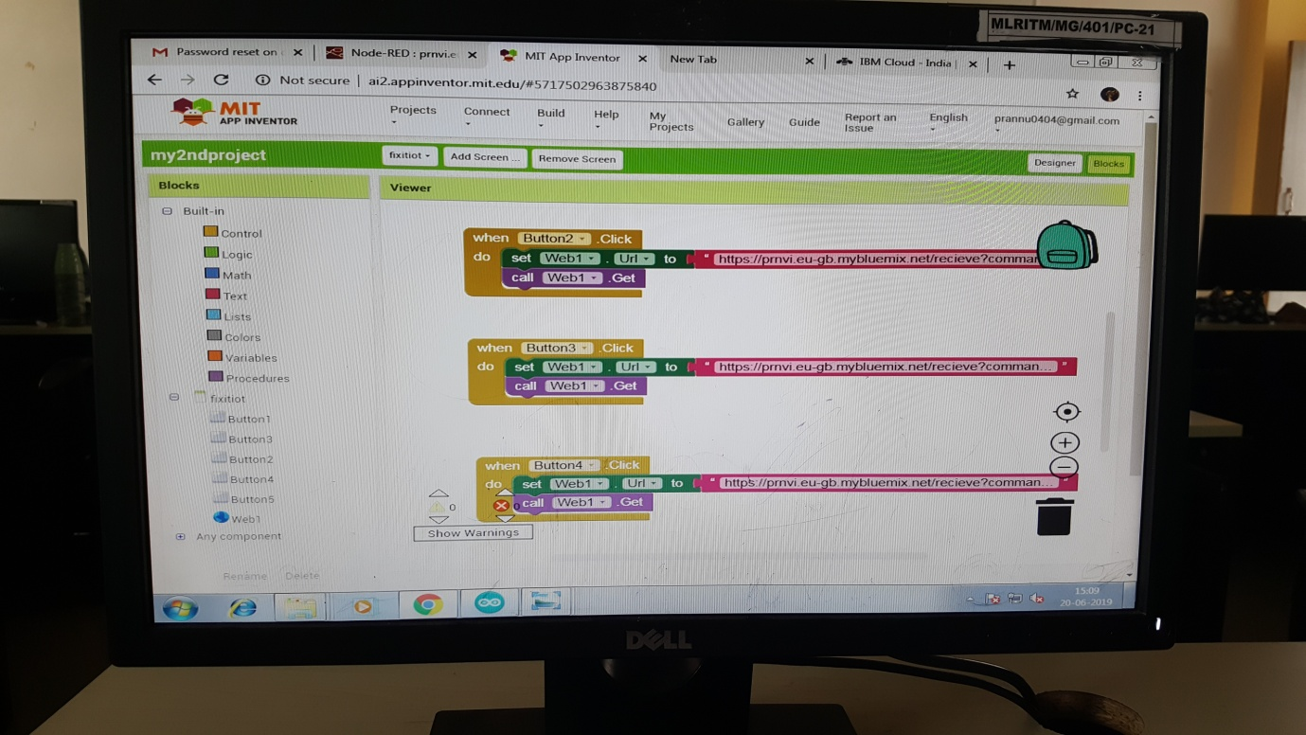

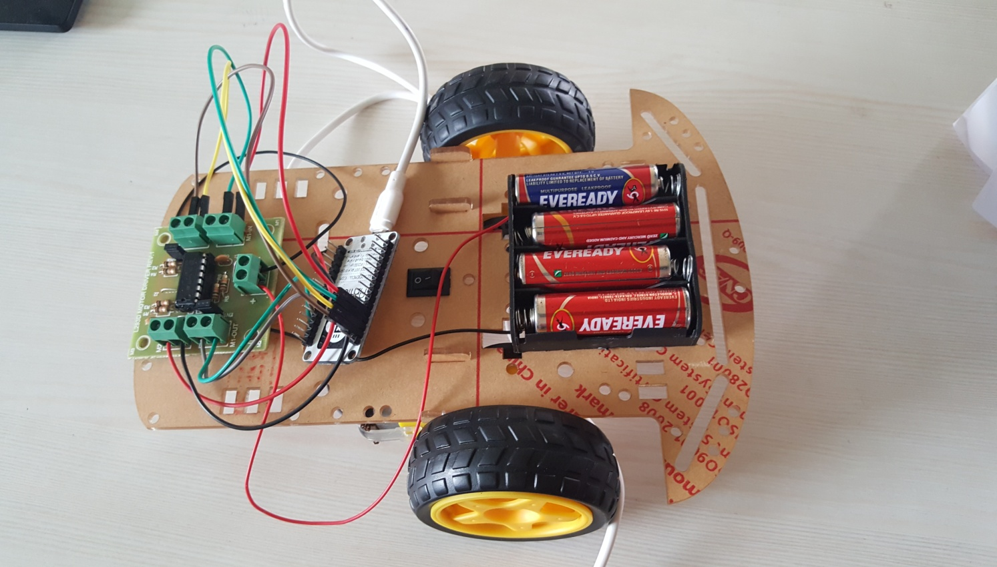

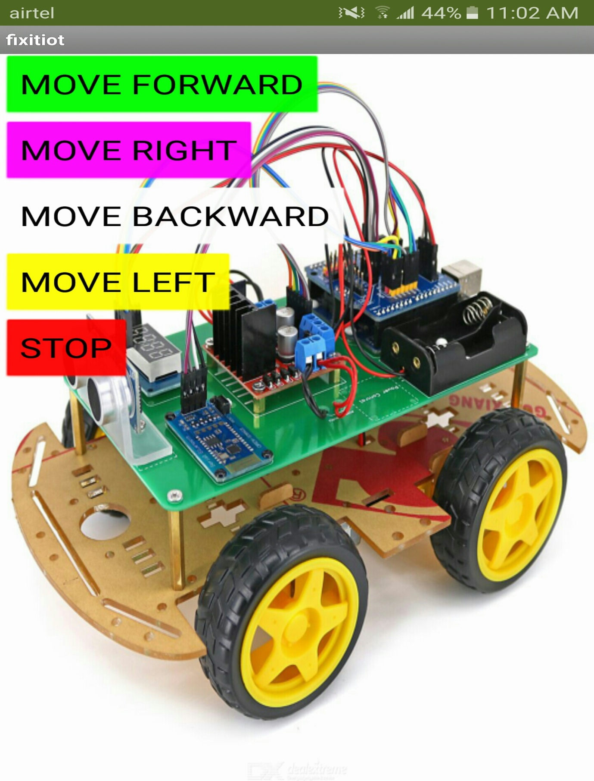

THANK YOU.......!!!!!